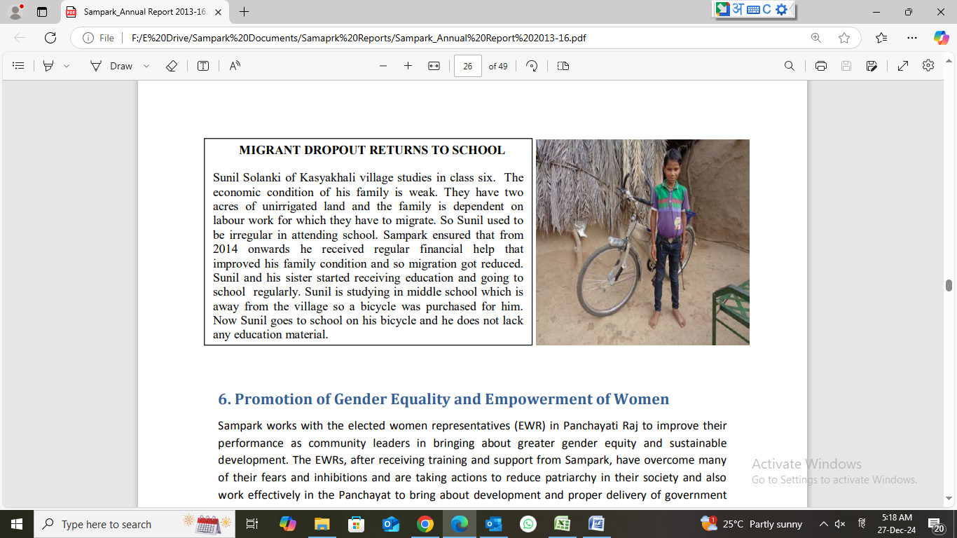
MIGRANT DROPOUT RETURNS TO SCHOOL Sunil Solanki of Kasyakhali village studies in class six. The economic condition of his family is weak. They have two acres of unirrigated land and the family is dependent on labour work for which they have to migrate. So Sunil used to be irregular in attending school. Sampark ensured that from 2014 onwards he received regular financial help that improved his family condition and so migration got reduced. Sunil and his sister started receiving education and going to school regularly. Sunil is studying in middle school which is away from the village so a bicycle was purchased for him. Now Sunil goes to school on his bicycle and he does not lack any education material

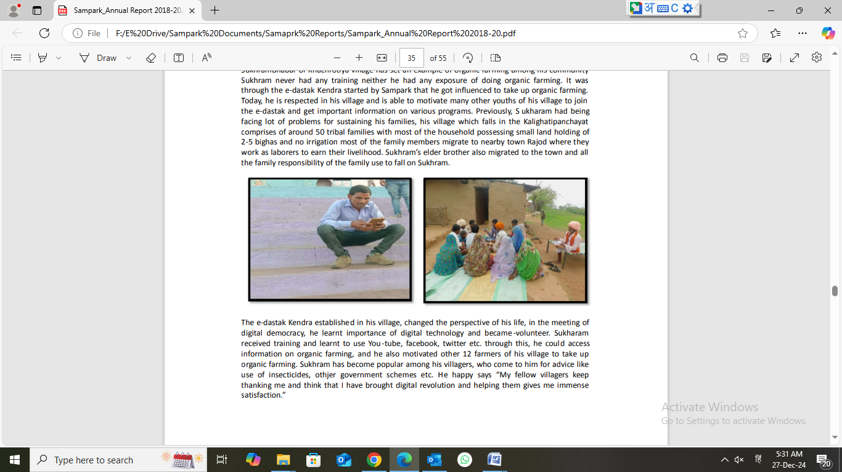
Case Study “The Digital Democracy – Revolution for the Villagers of Khachrotiya” SukhramBhabar of Khachrotiya village has set an example of organic farming among his community Sukhram never had any training neither he had any exposure of doing organic farming. It was through the e-dastak Kendra started by Sampark that he got influenced to take up organic farming. Today, he is respected in his village and is able to motivate many other youths of his village to join the e-dastak and get important information on various programs. Previously, S ukharam had being facing lot of problems for sustaining his families, his village which falls in the Kalighatipanchayat comprises of around 50 tribal families with most of the household possessing small land holding of 2-5 bighas and no irrigation most of the family members migrate to nearby town Rajod where they work as laborers to earn their livelihood. Sukhram’s elder brother also migrated to the town and all the family responsibility of the family use to fall on Sukhram. The e-dastak Kendra established in his village, changed the perspective of his life, in the meeting of digital democracy, he learnt importance of digital technology and became-volunteer. Sukharam received training and learnt to use You -tube, facebook, twitter etc. through this, he could access information on organic farming, and he also motivated other 12 farmers of his village to take up organic farming. Sukhram has become popular among his villagers, who come to him for advice like use of insecticides, othjer government schemes etc. He happy says “My fellow villagers keep thanking me and think that I have brought digital revolution and helping them gives me immense satisfaction.”

