Hard Work Pays”
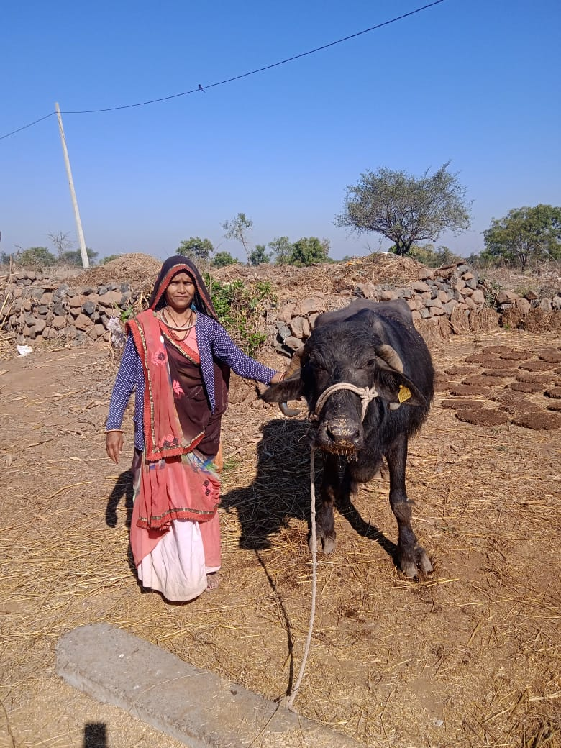
Ganga Bai w/o Karamchand Bhuriya belongs to a family of farmers in Khacrotiya village of Jhabua District. Her family is dependent on mearge income of farming and labor work making it difficult to survive, further finding labor work each day was another turmoil.

She came to know about the Mahila Shakti Sangh and its program in the village, getting motivated she became of the member of SHG.

For overcoming with the hurdles of her family, Pachudi Bai decided to start a Gouty Farming , for this she took up a loan Rs.20000/- to start her business. Now, she is been able to earn enough to
support her family and is also able to repay the loan to Sampark Mahila Shakti Sangh
Recently, she has also been able to purchase a Buffalo from her saving and Mahila Shakti sangh . As her happy face beams with a smile when she narrates her success story and is an encouragemen to her other village women.

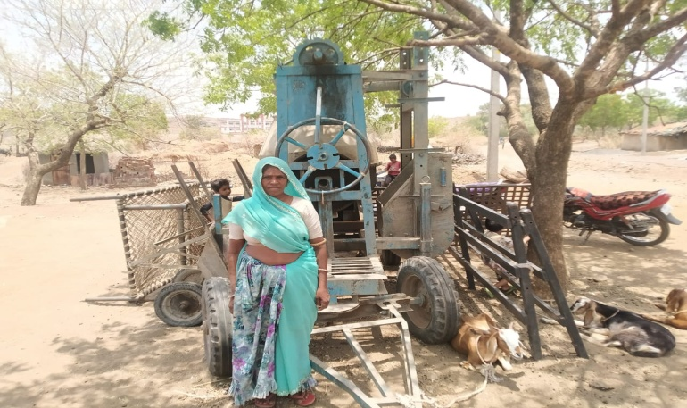
“A Motivating Example for the villagers of Kalighati”
Pachudi Bai belongs to adiwasi farmer’s family in Kalighati village of Jhabua district. Her family has 6 members, with major occupation being farming & labor work, she is able to gether a merge income of around Rs.1,00,000/- yearly.
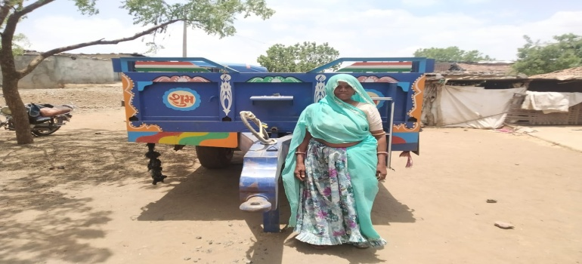
She is a member of Mahila Shakti Sangh and some of the meetings she got aware about the income generation activities taken up by some of her village women which were supported by Mahila Shakti Sangh through Micro Finance Program of Samaprk. She along with her family members decided to take loan of Rs.20000/- for purchasing Goat. . Then, Second time she decided to take a loan of Rs. 30000/- and purchase Mixer Machine for Construction work. Recently, she took another loan of Rs.40000/- from Mahila Shakti Sangh for purchasing tractor tolly, now her family lends tractor on rent
To other farmers and she is earning a good amount from this. Her confidence, honesty and disciplined savings and repayment behaviour has inspired many women in her community to follow her. She credits the Mahila Shakti Sangh for encouraging and equipping her to take such an entrepreneurial journey that has changed her family’s life for the better.

“Changing Her Life for Better – Nirmala Bai”
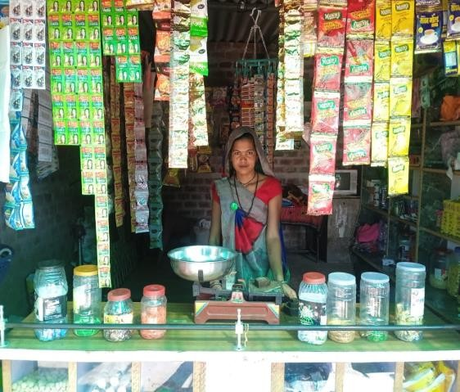Nirmala Bai, a resident of Kotda village, Petlawad bock of Jhabua District, is an living example of determination and success. With 4 members
in her family, there was a daily struggle of getting two square meals. Working as labourers, the earning of the family were not enough to meet the basis needs. Nirmala bai’s fate changed when came in contact with some of the members of Mahila Shakti Sangh, who encouraged her to join the group and take the benefit. Consulting her husband she became the member of SHG and decided to take a loan of Rs.20000/- for staring the grocery shop. As there was not a single shop in her mohalla, this was a wise decision from her side as she is getting customers from locality to purchase goods from her shop. She earns around Rs.300/- to Rs.400/- daily which is enough to
pay the EMIs and meet the some family expenses. She gives credit to Mahila Shakti Sangh and her friends who motivated her to be part of Mahila Shakti Sangh.

“Life becomes easy for Prakashi Bai’s Family”
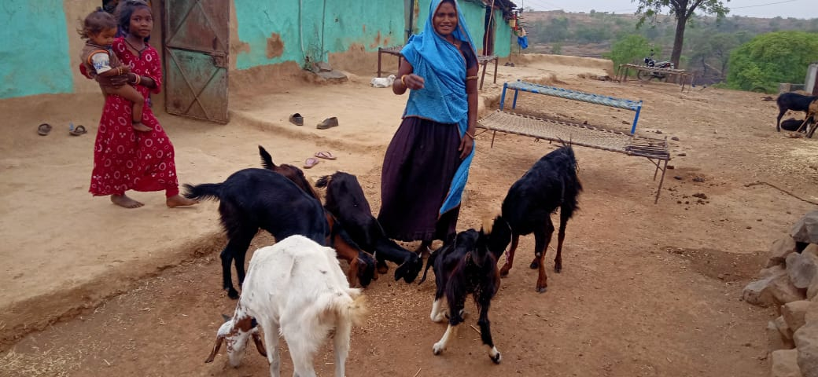
Prakashi Bai of Kachrotiya village, Petlawad block of Jhabua district feels relieved to be part of Mahila Shakti Sangh. Previously, her family struggled to get labour & farm work for sustenance. Prakashi and her husband always desired to have cattle in their house but due to financial constraints they were not able to gather courage to purchase one. Sangeeta came in contact with the SHGs group of village and got aware about the Micro Finance Program of Sampark. She became the member of the group and took loan of Rs.20000/- and purchased a Goat. She get Slowly Return but slowly they were able to repay the loans and again took Rs.30000/- loan for purchasing a Goat thus
the family is able to earn enough to meet the expenses without struggling
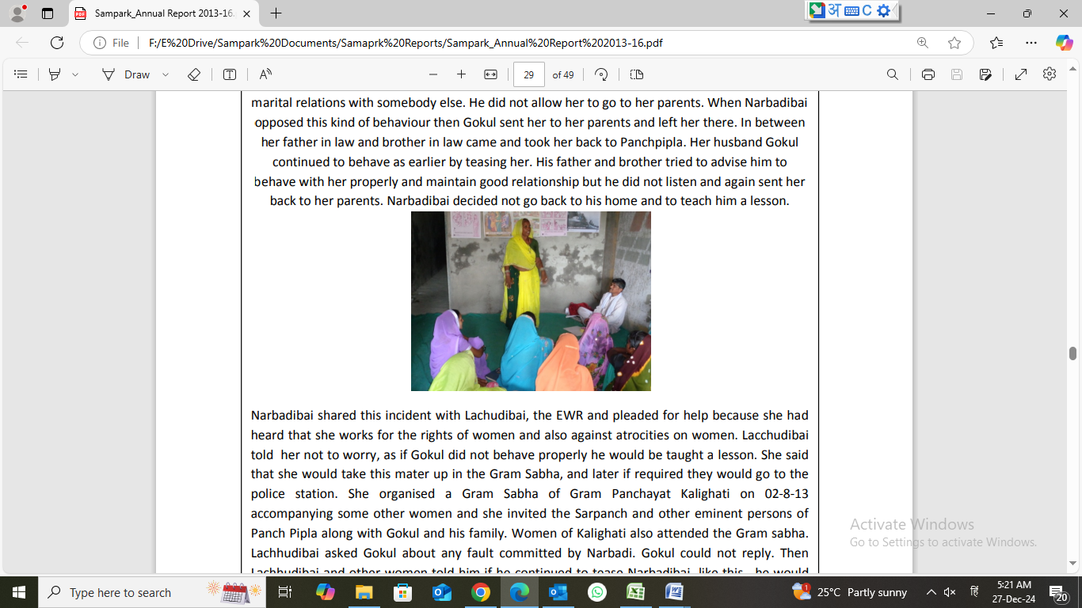
NARBADI GETS HER RIGHTS Gram Panchayat Kalighati is 30 kms away from Petlawad town. Here Bhil women are assumed by their men to be very weak. They are like puppets in the hands of men and they will do as directed by men. Smt. Narbadi bai was married to Gokul of village Panchpipla in 2012 at the age of 19 years. After three months of their marriage Gokul had a doubt that Narbadi was having extra marital relations with somebody else. He did not allow her to go to her parents. When Narbadibai opposed this kind of behaviour then Gokul sent her to her parents and left her there. In between her father in law and brother in law came and took her back to Panchpipla. Her husband Gokul continued to behave as earlier by teasing her. His father and brother tried to advise him to behave with her properly and maintain good relationship but he did not listen and again sent her back to her parents. Narbadibai decided not go back to his home and to teach him a lesson

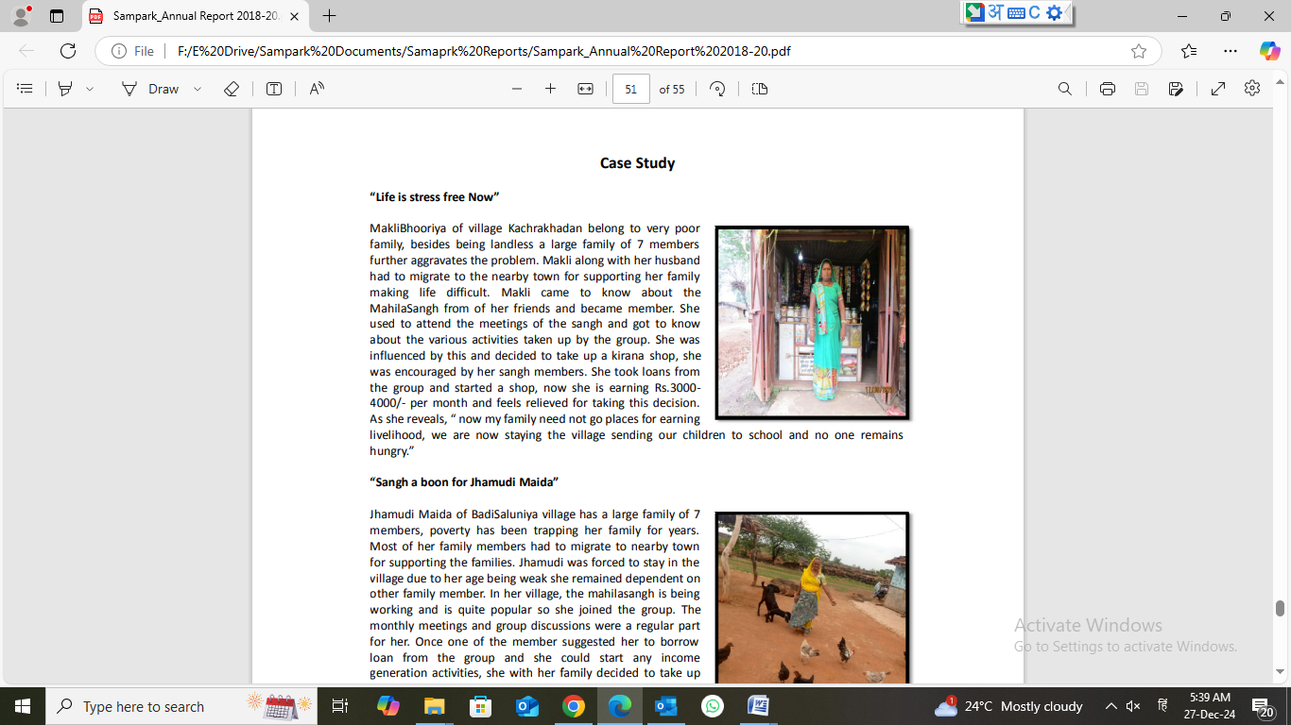
Case Study “Life is stress free Now” MakliBhooriya of village Kachrakhadan belong to very poor family, besides being landless a large family of 7 members further aggravates the problem. Makli along with her husband had to migrate to the nearby town for supporting her family making life difficult. Makli came to know about the MahilaSangh from of her friends and became member. She used to attend the meetings of the sangh and got to know about the various activities taken up by the group. She was influenced by this and decided to take up a kirana shop, she was encouraged by her sangh members. She took loans from the group and started a shop, now she is earning Rs.3000- 4000/- per month and feels relieved for taking this decision. As she reveals, “ now my family need not go places for earning livelihood, we are now staying the village sending our children to school and no one remains hungry.” “

Sangh a boon for Jhamudi Maida” Jhamudi Maida of BadiSaluniya village has a large family of 7 members, poverty has been trapping her family for years. Most of her family members had to migrate to nearby town for supporting the families. Jhamudi was forced to stay in the village due to her age being weak she remained dependent on other family member. In her village, the mahilasangh is being working and is quite popular so she joined the group. The monthly meetings and group discussions were a regular part for her. Once one of the member suggested her to borrow loan from the group and she could start any income generation activities, she with her family decided to take up poultry farming, she took credit of Rs.20000/- from the sangh. The activities seem to be fruitful and she earns Rs.2500- 3000/- per month, which is helpful the family need. Apart from this, her family also uses eggs whenever required. She feels grateful to the sangh which has helped her in supporting her family.

